SEMESTER PROJECT (MAD)

ALI HAMZA (021-19-0052)

ICON FOOD DELIVERY

Introduction:

As in our university we have cafe ICONS by Ghoris from which daily many student purchase foods. Not only students but everyone in SIBAU. The food chain is very much busy serving people of SIBAU. This application is designed for ICONs café and ICE-MAN Candy shop from which people living in SIBAU can order anything and they are supposed to deliver it. This application is android project in Kotlin language. It is opportunity for business to grow in the era of technology.

Problem Statement:

The main purpose of this application is to give the record of the items ordered. As mostly faculty call the café person and give them order sometime the person forgot some items and sometime faculty members wanted to order more but the order was completed so they have to call again. Next problem is for the delivery guy as he has to remember the locations and office number of every faculty member that have ordered food. If faculty member changes his/her location it is not possible to update it for that delivery guy. So, this app will be used for delivering food as it will show locations too.

Second main problem is that mostly students are living in internal hostel and if they want something from café they have to change the dress and then come to the café to get the food as you cannot come in the informal dress in university so it is hectic for students to change clothes. This application will solve this problem too.

Sometime for little refreshment in class you can get tea coffee for the whole class just sitting in the class and order it from this application instead of leave the lecture and go to the café for ordering and wait there until your order get ready and bring it up to class.

Screenshots:

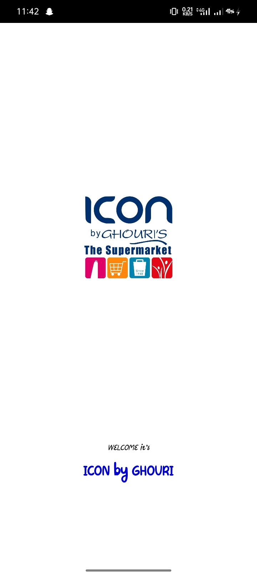

Login Page

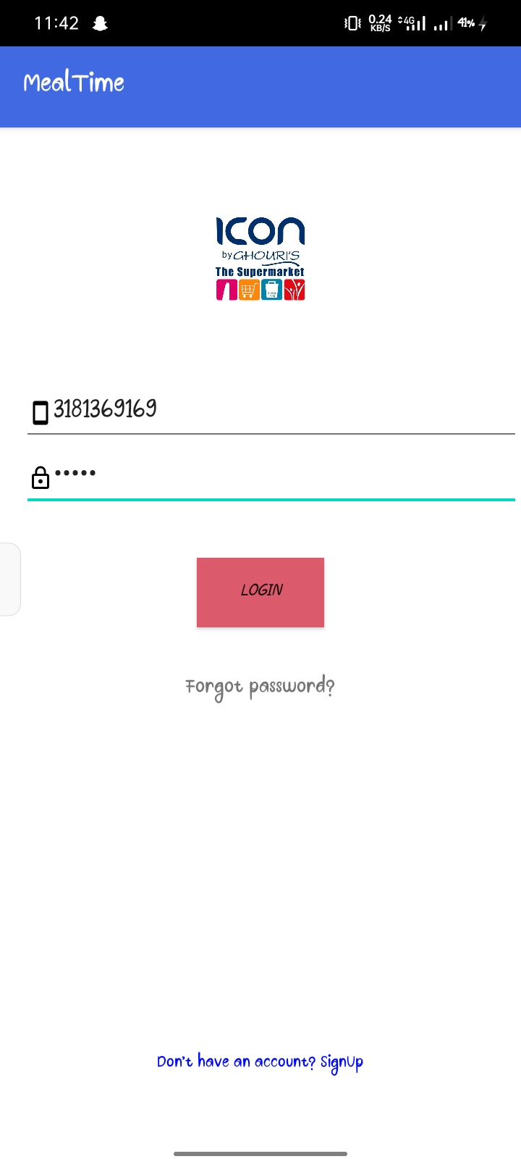

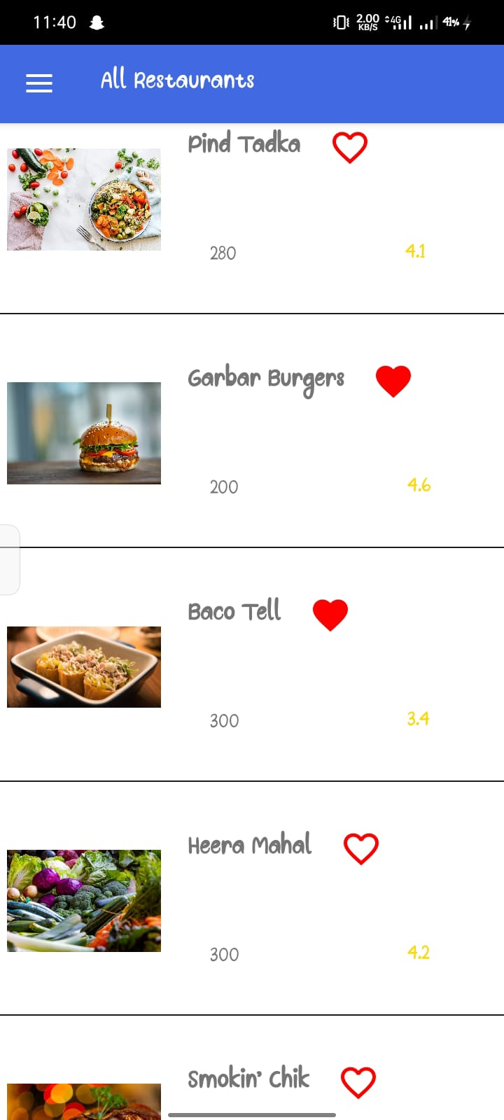Main Screens:

Google Drive Link:  
  
https://drive.google.com/drive/folders/15jnA5ckCsnf7oDPuG9khlNCI3DT677RY?usp=sharing